**CS 457/557 -- Winter Quarter 2018**

**Project #4**

**Image Manipulation in a "Magic Lens"**

Stewart Rodger

rodgers@oregonstate.edu

02/22/2018

After mapping an image to the quad, all the work is done in the fragment shader. The magnification is don by getting the center of the “magnifying glass”, dividing by the magnification factor, then adding the original center back to restore the position.

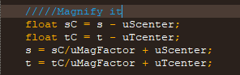

Rotation takes our magnified center value and uses sine and cosine to rotate it.

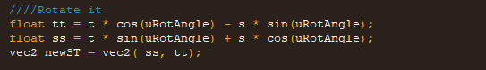

The sharpen code is from the class lecture/textbook, implemented to work with the other aspects of the project.

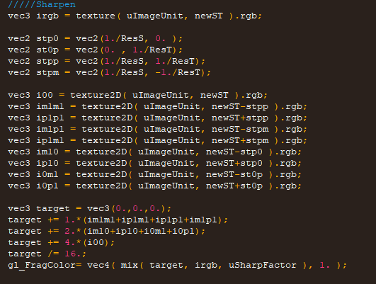

The result:

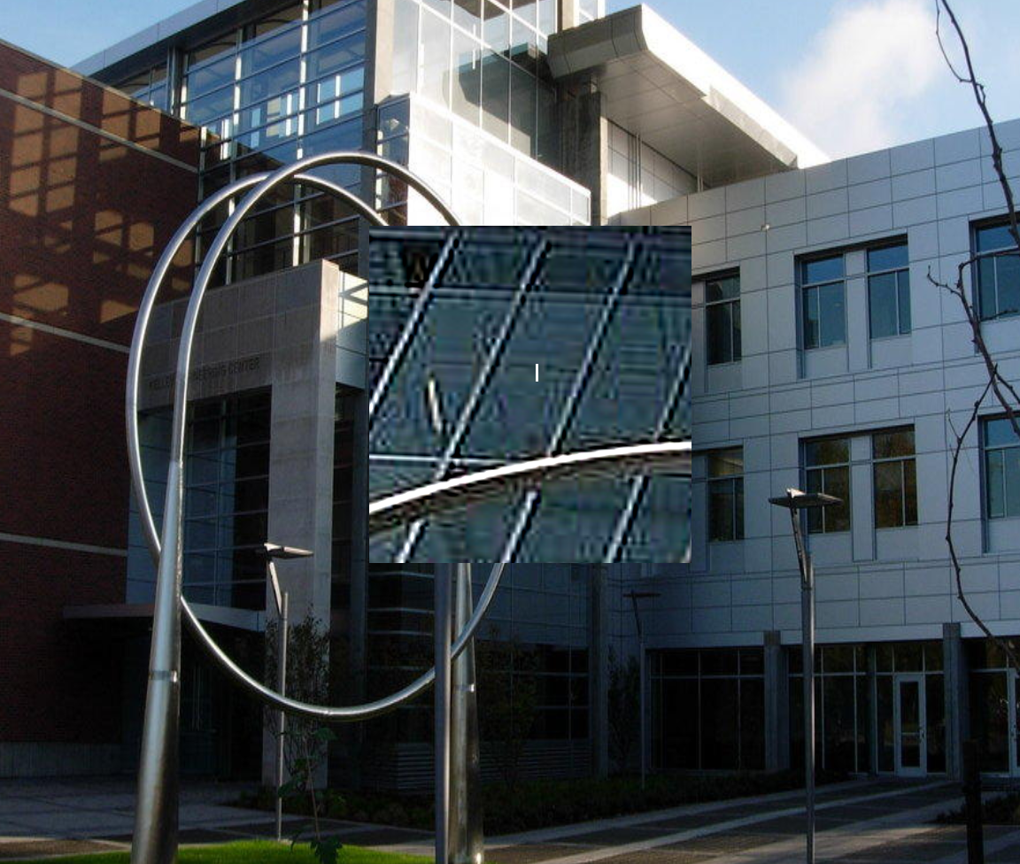

Link to the Kaltura Video Demonstration:

<https://media.oregonstate.edu/media/t/0_26bjogmf>